Predicting Average Lap Times for the 2024 F1 Abu Dhabi GP

Team Members: Kimaya and Ainsley
Course: Machine Learning

1. Introduction
Problem Type: Regression – predicting average lap time for each driver in Abu Dhabi (continuous metric).
Goal
- The objective of this project is to predict the average race lap time (in seconds) for each driver during the 2024 Abu Dhabi Grand Prix, using data extracted from every race in the 2024 Formula One season (except for the final i.e. Abu Dhabi).
- Lap time is influenced by driver skill, tyre compound, tyre life, circuit characteristics, weather, and car performance. Predicting it allows us to quantify how well machine-learning methods can identify pace differences and generalize from historical performance.
- Feature engineering also helps us understand what features are the most important when making real time decisions on the race track.
Methods & Approach
The project uses the FastF1 package to load telemetry, lap timing data, and weather information for all 24 races of the 2024 season. Key steps include:
- Data extraction from FastF1 (laps, tyre info, game weather, team and driver IDs).
- Feature engineering, including tyre age, circuit type (street vs. permanent), rainfall, average speed, and track-length-based lap normalization.
- Categorical encoding using OneHotEncoder for driver, team, compound, and circuit type.
- Model training using a Random Forest Regressor (main model) and driver-level averaging on the test set.
- Evaluation on the Abu Dhabi GP only, ensuring a realistic “future race prediction” split.
Evaluation uses RMSE, MAE, and R² metrics, focusing on how closely predictions match the actual driver averages.

2. Dataset Selection & Justification

2.1 Dataset Source
All data comes from the FastF1 Python library, which provides open-access Formula 1 timing and weather data.
Data loaded:
- Lap times
- Driver identity
- Team
- Tyre compound
- Lap number
- Weather (rainfall flag)
- Event metadata
2.2 Dataset Description
For each of the 24 races:
- Every lap driven in the race is recorded.
- Tyre and stint info (how many laps driven on which tyre), team, and driver are included.
- Lap times are converted to seconds.
- Circuit type is tagged (“Street” or “Permanent”) — manually entered.
- Average speed is computed using:
AvgSpeed=(Track Length (km))/(LapTimeSeconds/3600)
Final dataset size:
- Train Data: 23 races x 50-70 laps each x 20 drivers
- Test Data: 1 race (Abu Dhabi) x 58 laps x 20 drivers
2.3 Why This Dataset Was Chosen
- This dataset is public and accessible by anybody. It also consists of complete information about a specific driver for a specific race. Such high-resolution lap data suitable for quantitative modeling. Varying features also provide a realistic view of race conditions across varying circuits.
2.4 Dataset Limitations
- The dataset has several limitations: some telemetry is missing due to disabled telemetry loading, weather was reduced to a simple rainfall flag, and key factors like fuel load and ERS usage were not modeled. Additionally, occasional timing errors or unusually slow laps may remain and require further filtering.

3. Data Preprocessing & Exploration
3.1 Data Cleaning
The raw lap data extracted from FastF1 required several cleaning steps to ensure only valid race laps were used for model training. Any lap recorded under 30 seconds was removed, as such times are physically impossible and typically correspond to out-laps, in-laps, or parsing errors. Laps with missing or unparsed lap time values were also discarded to prevent the model from learning from incomplete samples. In sessions where weather information could not be retrieved, the rainfall variable was defaulted to 0 to maintain a consistent feature structure.
The code also computed tyre age at the driver level using a cumulative counter:
laps["TireAge"] = laps.groupby("Driver")["LapNumber"].cumcount() + 1
3.2 Normalization & Standardization
Lap times across races are not directly comparable due to different circuit lengths, so track lengths (in km) were manually defined for all 24 events in the 2024 season. Using these values, each lap was normalized to an average speed metric:
AvgSpeed = (Track Length (km))/(LapTimeSeconds/3600)
This converts each lap into a consistent speed-based performance measure. By normalizing in this way, the model evaluates driver pace relative to circuit length rather than relying on raw lap-time magnitudes, which vary dramatically between tracks.
This helps the model compare pace differences across circuits.
3.3 Feature Engineering
Several key features were engineered to capture performance-related characteristics:
- CircuitType – Encoded as Street or Permanent, allowing the model to learn differences in layout difficulty and track evolution.
- TireAge – Derived as described above, used as a proxy for tyre wear.
- Rainfall – A binary indicator (0 or 1) representing wet or dry conditions.
- AvgSpeed – The normalized lap performance metric used as the prediction target.
- LapNumber – To reflect stint progression and fuel burn-off.
- Team, Driver, Tyre Compound – One-hot encoded categorical features to avoid imposing ordinal relationships.
All engineered and encoded features were merged into the final modeling dataframe before being passed to the machine-learning models.
3.4 Exploratory Data Analysis
Although formal plots are not shown in the report, inspection of the processed dataset revealed several clear patterns:
- Street circuits tend to produce slower and more variable lap speeds due to tighter corners, lower grip, and safety-car interruptions.
- Tyre compounds follow expected performance deltas, with softer compounds reliably generating higher speeds early in a stint.
- Team-level differences were evident, with front-running teams consistently achieving higher average speeds across all circuits.
These observations informed feature selection and supported the interpretation of the model’s eventual predictions.

4. Model Selection & Implementation
4.1 Baseline: Linear Regression
This was planned but after testing we realised that the results it produced did not align with what we wanted. So only the Random Forest was used as our predictive model and serves as the main model.
4.2 Main Model: Random Forest Regressor
Model details:
RandomForestRegressor(n_estimators=500,max_depth=15,random_stat=42)
Chosen for:
- Ability to model nonlinear relationships
- Good performance on tabular data
- Robustness to noise
- Feature importance output
4.3 Train–Test Split
Train split = 23 races (rounds 1–23)
Test split = Abu Dhabi (round 24)
This simulates real-world future race prediction.
4.4 Hyperparameter Tuning
No tuning performed—model uses predefined hyperparameters.

5. Evaluation & Interpretation
5.1 Metrics
After our model was coded, we tested its accuracy by running statistical tests on our predicted results vs. the actual lap times that occurred (actual data from Abu Dhabi).
Final results:
- RMSE: 1.240 sec
- MAE: 1.038 sec
- R²: 0.281
Interpretation:
- RMSE (Root Mean Squared Error): Average prediction error is ~1.24 seconds. Shows some large driver-specific deviations.
- MAE (Mean Absolute Error): ~1.04 seconds average error—overall performance is moderately accurate for such a complex prediction task as things like weather, driver performance can change at any time.
- R² Score: 0.281 means the model explains ~28% of variance in average lap times.
Given the randomness in race conditions, this is respectable but leaves room for improvement.

5.2 Model Results
Predicted vs Actual Average Lap Time per Driver
The first plot:
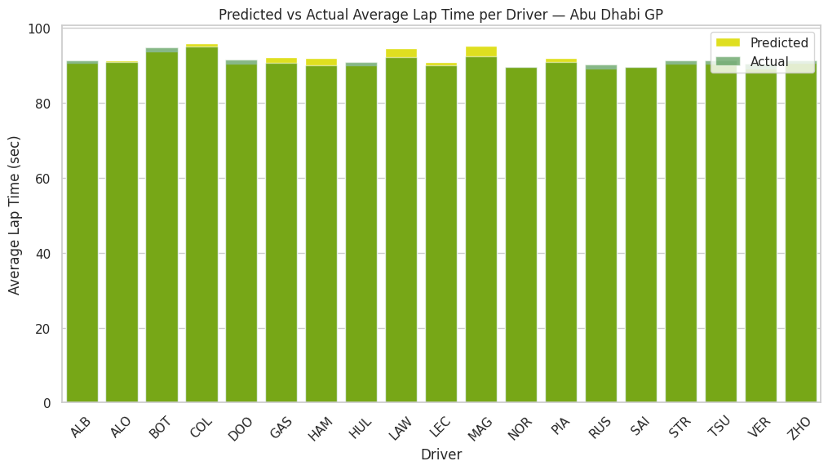
Drivers are shown along the x-axis using driver ID, with bars showing predicted vs actual lap times. Y-axis contains Average Lap Times in Seconds.
Key observations:
- Predictions almost always fall within 1–2 seconds of the actual average.
- The model correctly captures relative pace (faster vs slower drivers).
- Deviations occur mostly for:
  - MAG (+2.90 sec overprediction)
  - LAW (+2.26 sec overprediction)
  - HAM (+1.94 sec overprediction)
- Model underpredicts for:
  - VER (−1.28 sec)
  - BOT, DOO, RUS, STR, TSU all around −1 sec
These discrepancies likely come from race setup differences unique to Abu Dhabi or irregular stints. Could also be due to reasons out of our control; driver health, ERS/DRS usage, etc.

Prediction Error per Driver
Second plot:
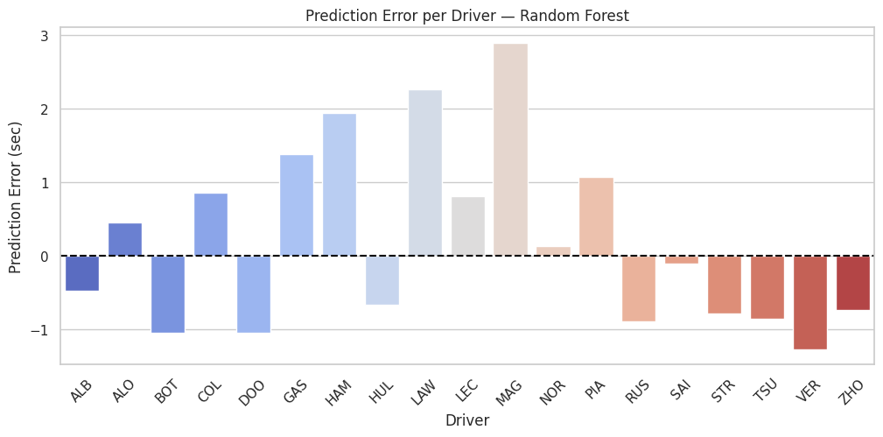
Drivers are shown along the x-axis using driver ID and Prediction Error is seconds is shown along the Y-axis. Vibrant colour palette is used for visuals.
Positive = model predicted too slow, Negative = model predicted too fast
Largest errors:
- MAG = +2.90 sec (much slower in reality than model expected)
- LAW = +2.27 sec
- HAM = +1.94 sec
- GAS = +1.39 sec
Largest negative errors:
- VER = −1.28 sec (model expected him to be slower than he actually was)
- BOT = −1.05 sec
- DOO = −1.04 sec
Interpretation:
- The model systematically overestimates lap times for certain drivers.
- Model struggles with drivers who performed exceptionally well or poorly in Abu Dhabi compared to season averages.

Feature Importance Plot
Third plot:
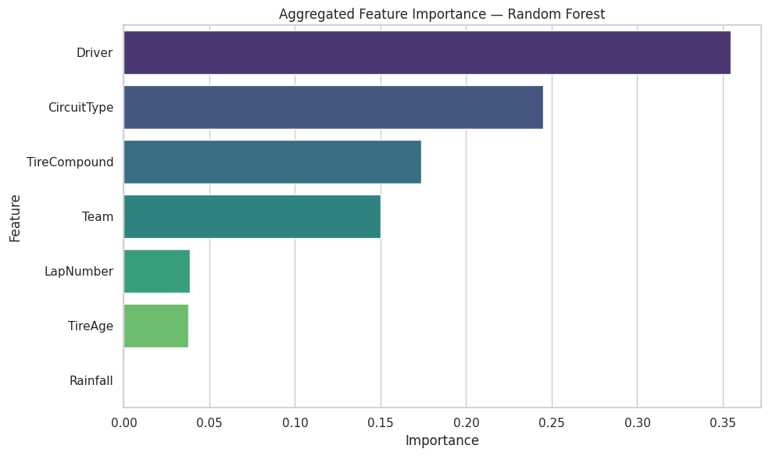
Aggregated importance shows:
- Driver – most important, as per expectations (~0.36)
- CircuitType – very important (~0.24)
- TireCompound (~0.17)
- Team (~0.15)
- LapNumber low importance – as per expectations
- TireAge low importance
- Rainfall near zero (since Abu Dhabi is dry)
Meaning:
- Drive-specific season performance heavily influences predictions.
- Street vs permanent circuits affect pace trends.
- Tyre Compound choice strongly influences lap time.
- Weather had minimal impact since most 2024 races are dry.

5.3 Interpretation of Findings
- Random Forest can predict driver pace trends, but struggles with unusual performances. Again, could be because of reasons completely out of control.
- Team- and driver-specific effects dominate lap-time prediction as per expectations.
- Tyre compound is a key factor, aligning with known F1 performance patterns.
- The model reasonably predicts “expected” behavior but is less accurate with race-specific anomalies.

5.4 Limitations
- Weather and ERS/fuel load are not modeled explicitly.
- FastF1 rainfall data is simplified. Detailing the features like including track temperature, wind speed, atmospheric temperature could make it more accurate.
- No telemetry was used—removing valuable predictive power like throttle, speed, braking.
- Driver performance variability unique to Abu Dhabi is not captured.

6. Literature Review
6.1 Similar Projects
- Mariana Antaya (GitHub https://github.com/mar-antaya/2025_f1_predictions )
- Nitya Mehta (Medium https://medium.com/@nityachintan/how-i-built-an-f1-race-prediction-app-as-my-first-machine-learning-project-7e2e9cc89826 )
6.2 What We Add
- Predicting average lap time (not position)
- Use of normalized lap metrics (all completed laps used)
- Analyze the influence of the used features — driver and circuit type were the most influential.

7. Code Quality & Documentation
7.1 Downloads and Imports
- Install FastF1 Dataset
- Pandas, Sklearn, One Hot Encoder, Random Forest Regressor, Matplotlib, seaborn, MSE, MAE, R2_Score, numpy
7.2 Code Practices
- Functions
- Variable naming
- Comments and docstrings

8. Conclusion
- What our models achieved
  - We were able to predict a lap time for each driver for the 2024 Abu Dhabi Grand Prix and compare it to the actual time, which were very similar values. Statistical tests were also in our favour
  - Used multiple features, especially the most important ones, to predict values and compare the influence of each feature on the predicted lap times
- Key insights
  - The weather was not as influential a feature in averaging lap time predictions as we expected, but then again Abu Dhabi is mostly dry
  - The actual numbers below and exceeding the prediction are quite even across the performance of the drivers; half did worse and half did better than expected
- What could be improved
  - Create a table or csv of data we were using and have the dataset downloaded once so it doesn’t take a long time to run the code each time to read through the dataset
  - Testing more features like throttle usage, break %, etc. and narrowing down the best combination — also the most important one
  - Making the code more adaptable to updating data with different features, better UI/UX and easy to play around with
  - Compare models to see how sets of features perform in different environments

